**Effect of Audio Waveform in Haptic Perception of Electro vibration on Touchscreens**

Deepthy Rose Jose

AM20S052

**TABLE OF CONTENTS**

1. **ABSTRACT**
2. **INTRODUCTION**
3. **HISTORY: AUDIO-TACTILE PERCEPTION AND INTEGRATION**
4. **SYNTHESIS OF AUDIO-TACTILE STIMULI**
5. **AUDIO WAVEFORM: UNDERSTANDING FEATURES AND EXPLANATIONS**
   1. [**THE WAVEFORM DIAGRAM**](https://swphonetics.com/praat/tutorials/understanding-waveforms/#diagram)
   2. [**SINUSOIDAL WAVES**](https://swphonetics.com/praat/tutorials/understanding-waveforms/#sinewave)
   3. [**PERIODICITY**](https://swphonetics.com/praat/tutorials/understanding-waveforms/#periodicity)
   4. [**AMPLITUDE**](https://swphonetics.com/praat/tutorials/understanding-waveforms/#amplitude)
   5. [**FREQUENCY**](https://swphonetics.com/praat/tutorials/understanding-waveforms/#frequency)
   6. [**TRANSIENTS**](https://swphonetics.com/praat/tutorials/understanding-waveforms/#transients)
6. **SYNTHESIS OF HAPTIC CLIPS**

**6.1 COMPOSITION USING ANDROID**

**6.2 COMPOSITION USING HAPTIC COMPOSERS**

1. **APP DESIGN**

**8.1 BASIC SOUNDS**

**8.2 EXPERIMENTAION**

**8.3 DEVICE REQUIREMENTS**

1. **RESULTS**
2. **RESOURCES**
3. **Abstract**

*The perceived intensity of electro vibration can be altered by modulating the amplitude, frequency, and waveform of the input voltage signal applied to the conductive layer of a touchscreen. This project investigates how audio waveform / signals can be used to compose haptic feedback. The following is aided by Vibration compose features of the new android version 12, haptic composers such as Lofelt Studios and audio analyzer such as Audacity.*

1. **Introduction**

Haptics, the science of sensing through touch, is at the root of how we communicate and execute everyday actions. Drinking a glass of water, typing on a keyboard or even walking relies on haptics, through force feedback stimulation of mechanoreceptors. Thousands of such receptors in our skin convert mechanical information into electric signals to muscles that allow us to move our body as we desire.

Surface haptics has recently gained a growing interest by the haptics community due to the popularity of touch screens used in a variety of electronic devices. The current studies on surface haptics have focused on displaying efficient tactile feedback to a user as the user moves her/his finger on the screen.

In recent years, multimodal interaction has become increasingly relevant in human-computer interfaces. Often following an ecological approach, several researchers now take into consideration multiple sensory modalities that humans employ during their interactions with the surrounding environment or the act of playing a traditional musical instrument. From the investigation in a multimodal and ecological perspective of such consolidated everyday experiences, researchers aim at achieving seamless interaction and at enhancing the user’s performance on novel interfaces, spacing from digital musical instruments to computer desktops, smart objects, virtual and augmented environments. In this eﬀort, besides traditional and novel visualization paradigms, researchers are especially focusing on auditory and haptic display concept. With regard to the haptic modality, it can be noticed that current human-machine interfaces are mostly input-only, that is they are able to track some basic user’s gestures, while they only oﬀer tactile/kinesthetic feedback as by-product of their built-in mechanics. Also, the use of on-speech auditory feedback is often limited to simple iconic messages, which are far from the complexity and information content of sounds produced in our everyday InterAction with the world.

Audio-tactile perception and inte-

gration

Audio-tactile perception and inte-

gration

1. **History: Audio-tactile perception and integration**

In order to design audio-tactile interactions, systematic knowledge is needed of psychophysical mechanisms related to the integration of the auditory and haptic channels.

Touch and hearing both process vibration-based information transduced by diﬀerent receptors in the skin and the ear, respectively. The integration of haptic and auditory sensory information generally leads to an increased response compared to unisensory stimuli. Recent evidence of audio-haptic integration includes facilitated detection of an auditory stimulus and increased auditory loudness in the presence of a synchronous tactile stimulus. Of special interest is the human sensitivity to perceiving auditory and haptic information as coming from a common source, which has been studied for time synchrony in various setups from ﬁnger tip to whole body stimulation.

In the auditory and tactile roughness sensations are both used to create a multisensory sensation of roughness, while in it is shown that the tactile sensation can be biased by the spectral content of auditory cues. Often research in the ﬁeld refers to perception in isolation of the motor function. Everyday interactions however happen mostly within the loop of perception, decision-making and motor action in terms of desired eﬀect. Integration of audio-tactile cues and their relative importance to intention and action has been explored to some extent in the auditory domain, and research has been done into cognition within the action-perception loop in the visual-tactile and audio-tactile domains.

1. **Synthesis of audio-tactile stimuli**

Acoustic and vibrotactile signals share a common underlying physical nature, since they are both products of mechanical vibrations. Indeed, when a tangible object vibrates, it may enter a resonance regime and produce audible sounds. According to such observation, vibrotactile rendering may be driven by audio signals, which are possibly equalized to match the sensitivity of the human somatosensory system.

Two main approaches are found concerning the use of audio-haptic signals:

1. sets of perceptually meaningful signals (e.g., simple waveforms, sound samples) that form a semantics;
2. interactive simulation of realistic audio-haptic feedback by means of physics-based models. In particular physics-based models are found to enable a strict coherence between haptic and auditory cues, moreover they often expose control parameters that have direct correspondence with physical quantities (e.g., velocity, force, displacement), allowing direct mapping with the user’s gesture via tangible interfaces. Also, interactions with such models show physically-consistent behaviors (e.g., increasing the impact velocity results in both louder and brighter sounds).

A number of software frameworks exist, which enable the synthesis of haptic signals in virtual environments. The Sound Design Toolkit (SDT, available at http://www.soundobject.org/SDT/) is an open-source soft-ware product, suitable for research in audio-tactile interaction design. It consists of a library of physics-based/inspired algorithms for sound synthesis and control. As an example, a “crumpling” model was developed, which simulates the statistics of short sonic transients giving rise to crackling noise. The model drives a nonlinear impact model that soniﬁes every transient, and can be parametrized depending on the physical attributes of the simulated material. The numerical simulation of physical models poses some computational, stability and accuracy issues, especially when they include nonlinearities. In those issues have been studied and addressed for the nonlinear impact model used in the SDT.

1. **Audio Waveform: Understanding Features and Explanations**

A waveform is an image that represents an audio signal or recording. It shows the changes in amplitude over a certain amount of time. The amplitude of the signal is measured on the y-axis (vertically), while time is measured on the x-axis (horizontally).

Most audio recording programs show waveforms to give the user a visual idea of what has been recorded. If the waveform is very low and not pronounced, the recording was probably very soft. It the waveform almost fills the entire image; the recording may have been too "hot" or recorded with the levels set too high. Changes in a waveform are also good indicators as too when certain parts of a recording take place. For example, the waveform may be small when there is just a vocalist singing, but may become much larger when the drums and guitar come in. This visual representation enables audio producers to locate certain parts of a song without even listening to the recording.

The basic features of waveform diagrams:

* 1. [The waveform diagram](https://swphonetics.com/praat/tutorials/understanding-waveforms/#diagram)
  2. [Sinusoidal waves](https://swphonetics.com/praat/tutorials/understanding-waveforms/#sinewave)
  3. [Periodicity](https://swphonetics.com/praat/tutorials/understanding-waveforms/#periodicity)
  4. [Amplitude](https://swphonetics.com/praat/tutorials/understanding-waveforms/#amplitude)
  5. [Frequency](https://swphonetics.com/praat/tutorials/understanding-waveforms/#frequency)
  6. [Transients](https://swphonetics.com/praat/tutorials/understanding-waveforms/#transients)
  7. **The waveform diagrams**
* Figure 1 illustrates the waveform of the simplest type of sound. Simplest, that is, in the sense that it consists of just one tone, with no other sound mixed in. Theoretically, this is the sound of a tuning fork. It’s not easy to find a natural simple tone. Whistling or some birdcalls are possible examples. But it only needs one other tiny sound component added to it, and it’s no longer a simple tone.

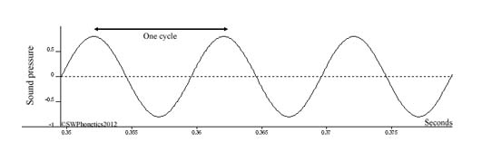

Figure 1. Audio Waveform- Tuning Fork

* The vertical scale represents sound pressure, the horizontal scale represents time.
* So, the diagram is showing how pressure varies with time. Not just any pressure, but the sound pressure of this particular tone relative to the atmospheric pressure, which is 0 sound pressure.
* The sound pressure rises and falls above and below the atmospheric pressure – alternating between denser and thinner, between compression and rarefaction.
* The sound pressure scale goes from positive to negative to accommodate that alternation. The values of the sound pressure scale (-1 to +1) are arbitrary. This is also what you will see when you look at the waveform of a speech recording in Praat (speech analysis software). The standard unit of pressure is Pascal, but the true Pascal values can only be shown for a recording when it has been calibrated for measuring Pascal.

### ****Sinusoidal waves:****

Now look at the shape of the wave in [Fig. 1](https://swphonetics.files.wordpress.com/2012/03/wavsin01.jpg). This one is sinusoidal; it happens to be exactly the same shape as that of the sine function. This gives a special meaning to *simple tone*. As soon as the shape of the waveform differs from sinusoidal, it is no longer a simple tone but a complex sound with more than one component. The sine wave is one example of a number of basic waveforms with known properties.

### ****Periodicity****

The wave in also appears to be repetitive as it alternates between compression and rarefaction. A wave that repeats like this is said to be *periodic*, and the smallest repeating segment of the wave is the *cycle.*

In contrast, the waveform of speech is complex and variable, reflecting the variety of vowels and consonants that are used and the dynamic nature of speech articulation with one or more articulators usually in motion at any time.

<https://www.youtube.com/watch?v=ChSVf9lZ44k>

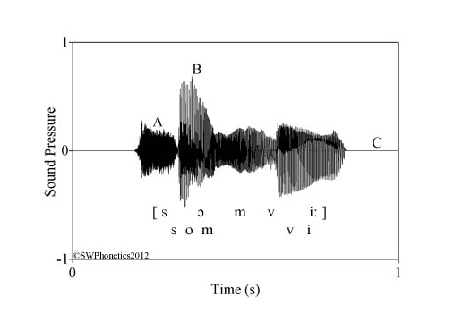

Figure 2. Shows a speech example from Swedish.

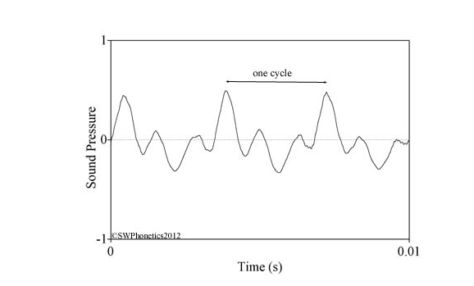

Figure 3 The waveform of three cycles from the vowel sampled at time B..

* The strict criterion of periodicity is the repetition of identical activity, something that rarely, if ever, happens in speech. Compare these three cycles in Fig. 3. They’re superficially similar but they differ in various details. For practical purposes, this is nevertheless regarded as periodic, loosely if you wish, or quasiperiodic.
* The periodicity of this example comes from the glottal vibrations of the voice. This is a complex waveform (its shape is definitely not sinusoidal), the components being the partial, or harmonic, tones of the voice. It was Jean-Baptiste Fourier (1768-1830) who discovered that any periodic function can be expressed as the sum of sine functions. *Fourier analysis* (or a fast version, *fast Fourier transform* or *FFT*) is still used to resolve complex waveforms into sinusoidal components.
* Before leaving periodicity, Fig. 4 shows an example of a wave that is *aperiodic* (not periodic).

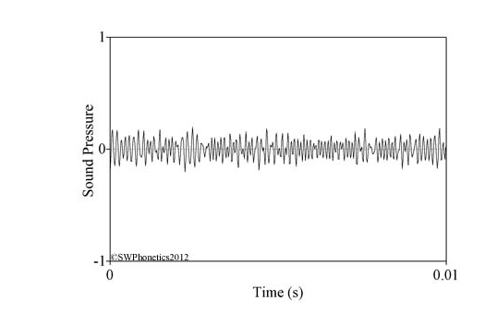

Figure 4. The waveform of 0.01secs sampled from the consonant [s] at A in Fig. 2

* This is the same time span, 0.01secs, as the three cycles seen in Fig. 3. There’s no regularly repeated pattern of activity in Fig. 4, all alternations between compression and rarefaction are random. This is the hissing sound of the consonant [s] in *som*, and the aperiodic waveform reflects the random character of the turbulent airstream created in the vocal tract for this type of consonant.

### ****Amplitude****

* The magnitude of the sound pressure alternations, measured from 0, is known as *amplitude*. For example, the activity at B in [Fig. 2](https://swphonetics.files.wordpress.com/2012/03/somvi01.jpg) has an amplitude of about 0.6 on this arbitrary scale, while the activity at A has an amplitude of about 0.2. Amplitude corresponds roughly to loudness, or audibility (but only roughly, because hearing is also dependent on tone height; we do not hear very low or very high tonal ranges so well; (more in the next section on *frequency*).
* The amplitude at C in Fig. 2 is 0, i.e., silent. Brief moments of silence occur during the occlusions of unvoiced stop consonants. But there are no silent gaps between words in everyday speech. But there are regular breathing pauses that might or might not be silent depending on audible respiration.
* Silence in a recording is also relative. A speech recording made in a room with loud ventilation, or busy motor traffic outside, will have a constant background noise that obscures “silent” moments in the speech. That’s why speech recordings intended for analysis are made in as silent conditions as possible, to ensure that you are measuring speech features and not something else.
* The weakest audible sound, if your hearing is perfect, is like the rustling of a single leaf at one metre distance. Don’t bother trying. In the real world, that leaf will be drowned by all the other noises of modern life. And in any case, the wind that makes it rustle will be more audible.
* Note that 1 and -1 on this scale do not represent the maximum or pain threshold of human hearing. It represents the performance limit of the audio equipment used all the way from the person speaking and through your computer. For Fig. 2, that means all the way from the radio studio microphone and amplifiers, through the radio transmitter and my receiver, and into my computer. In practice there are even lower limits. The closer a signal amplitude gets to 1, the more likely it is that some electronic components will introduce distortions. That’s why you’re usually safe when recording to a level around 0.5, but beyond that most recording equipment will start flashing yellow as a warning, and finally red to let you know that disaster has already occurred
* These examples demonstrate that sound pressure amplitude is related to energy. Higher sound pressure means more energy in the sound wave. Increase the sound pressure by 6dB and the energy will be doubled; increase sound pressure by 12dB, and the energy will be quadrupled, and so one. The more energy you have in the sound wave, the more likely you are to damage something.
* The trumpets at Jericho were reputed to have destroyed the city walls. Organs have to be carefully designed to match them to the building where they will be installed, to avoid causing structural damage. There was a time when earphones were so sensitive, they were destroyed by a strong electric audio signal before your ears were damaged. Today, earphones are so robust they can survive a signal that is strong enough to damage the ears.
* The ear transforms acoustic energy into nerve impulses at the hair cells of the cochlea. The acoustic energy bends a hair cell, prompting it to emit an impulse. Excessive energy bends hair cells too far, weakening or permanently destroying them. Natural sounds are usually tolerable, at distances from the source that are safe from other injuries (thunderstorms, landslides, volcanic eruptions and so on). Primates in trees should be safe from excessive sound. Hammering sounds (repeated impulses rather than continuous sound) are dangerous, so makers of flint tools must have experienced occupational hearing loss.
* Your first rock concerts or other severe noise exposures might weaken your hearing for hours. Subsequent warning signs include weakened hearing for a day or more, or intermittent tinnitus (a sensation of ringing). Continued exposure leads to permanent tinnitus or hearing loss.

### ****Frequency****

* *Frequency* expresses how often something happens – one birthday a year, ten rainy days a month, four London trains an hour, and so on. That is, defined incidents per time unit.
* The *frequency* of a periodic wave is the number of cycles that occur per second. Look again at the sine wave in [Fig. 1](https://swphonetics.files.wordpress.com/2012/03/wavsin01.jpg). Referring one cycle to the time scale, its duration is 0.01 secs, corresponding to a frequency of 100 cycles per second (100cps or 100Hz). In the real world this corresponds to a tone towards the bottom of the bass singing range, or near the bottom of the adult male speaking range. An *octave* above this (double the frequency for an octave) is 200Hz, near the top of the adult male speaking range or the lower part of the adult female speaking range. An octave higher again (double the frequency once more) is 400Hz, the middle of a child’s speaking range, and close to the 440Hz of a standard tuning fork. Finally, one more octave above this is 800Hz, near the top of the soprano singing range.
* Now look at [Fig. 3](https://swphonetics.files.wordpress.com/2012/03/somvi01o.jpg) again. The duration of one cycle there is 0.035secs, so the corresponding frequency is 283Hz. This is in the upper part of the speaking range of adult female voices.
* The complex vowel sound of [Fig. 3](https://swphonetics.files.wordpress.com/2012/03/somvi01o.jpg) is composed of a series of tones spaced with an interval equal to the cycle frequency. You cannot see these component tones just by looking at the wave, they have to be calculated. For this example, the cycle frequency happens to be 283Hz, so the series continues with 566, 849, 1132, 1415 … etc. Hz. All these component tones are known as*partials*, or *harmonics*. Alternatively, the lowest (first) partial is referred to as the *fundamental frequency* and the others as *overtones*.
* We do not hear acoustic activity equally well at all frequencies. The activity we hear best is roughly between 2000Hz and 5000Hz. Telephone communication is usually limited to about 300Hz-3500Hz. Most speech activity occurs between 100Hz and 8000Hz. With absolutely perfect hearing we might hear down to 20Hz and up to 20000Hz. The lowest note on a piano might be around 50Hz.
* *Subsonic* and *infrasound* refer to sound vibrations below 20Hz. *Ultrasonic* and *ultrasound* refer to sound vibrations above 20000Hz. *Supersonic*, on the other hand does not refer to frequency but to velocity (faster than the speed of sound, 350m/s or 1235km/h).

### ****Transients****

* A *transient* is a sudden and brief burst of acoustic energy, for example a bursting firecracker, the snap when you break a branch, a handclap. Transients occur in speech as the plosive releases of stop consonants.
* Figure 5 is an example of transients in speech, the plosive release of [t].

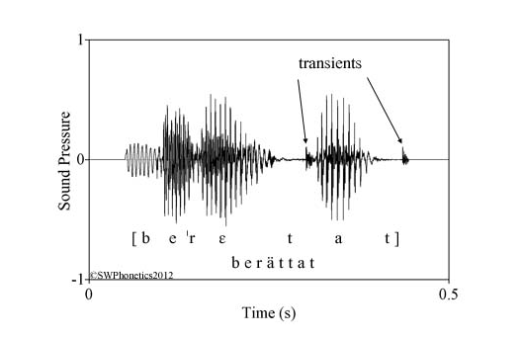

Figure 5. Waveform of the Swedish word berättat (told) spoken by a newsreader.

* Figure 5 has two examples of [t] bursts, shown by the arrows. The transients look like sharp spikes. The fuzzy looking activity following these two transients is aperiodic activity, the aspiration phase that is typical of Swedish unvoiced stops.

1. **SYNTHESIS OF HAPTIC CLIPS**

We receive haptic sensations nearly every moment of our lives. They are natural phenomena that are part of our human experience. We are continuously sensing motion, pressure, temperature and vibrations through our bodies.

Vibrations are closely related to sounds. Both vibrations and sounds begin with events that create some kind of physical pressure variation—such as a door slamming shut, a car revving its engine, or someone walking past us. Sound is what we perceive when the pressure variation propagates through the air and stimulates our ears. Vibration is what we perceive when the pressure variation propagates through solids and liquids, stimulating our skin.

Our brains understand the correlation between sounds and vibrations. And in fact, our brains expect this correlation. We expect certain vibrations to accompany particular sounds—like the deep vibrations we feel when we hear thunder. Technologies that can combine sound and vibration produce very rich, engaging experiences.

Technology vendors began incorporating basic vibrotactile feedback into pagers, early cell phones and gaming devices decades ago. But in most cases, these haptic experiences served merely as notifications: a cell phone would rhythmically vibrate when it was in “silent” mode. Until recently, technologies could not truly integrate sounds and vibrations to create immersive experiences.

Today, with the increasing availability of high-quality audio and visual content, users have come to expect more from their devices, including high-quality haptic feedback. And fortunately, next-generation actuators can deliver a wider range of vibrations to produce more nuanced sensations.

* 1. **STEPS TO CONVERT AUDIO TO HAPTIC FEEDBACK USING AUDIO ANALYSERS**

SOFTWARE USED: AUDACITY (Audio Analyzers)

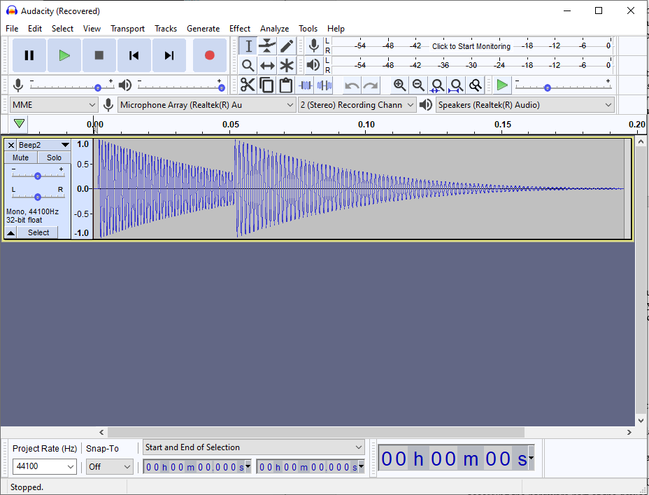

Figure 6. Amplitude and Frequency analysis of Beep 2 Audio using Audacity

**Steps for Amplitude and Frequency Analysis**

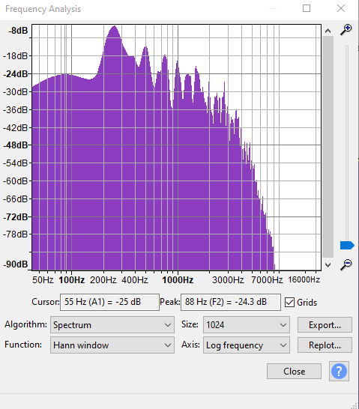

* 1. Select the File > Import > Audio... command, then choose one or more audio files, Audacity will import the selected file(s) into the existing project.
     + - For uncompressed audio: most WAV and AIFF files including all PCM variants can be imported into Audacity
       - Compressed audio: Ogg Vorbis, FLAC, MP2 and MP3 can be imported into Audacity.
  2. Analyze > Plot Spectrum
  3. Export
* *Plot Spectrum takes the selected audio (which is a set of sound pressure values at points in time) and converts it to a graph of frequencies (the horizontal scale in Hz) against amplitudes (the vertical scale in dB).*
* Plots are made using a mathematical algorithm known as a Fast Fourier Transform or FFT. This gives a value for each narrow band of frequencies that represents how much of those frequencies is present. All the values are then interpolated to create the graph.
* Plot Spectrum take the audio in blocks of 'Size' samples, does the FFT, and averages all the blocks together.
* The following set of data will be used to feed the compose feature of android vibration.

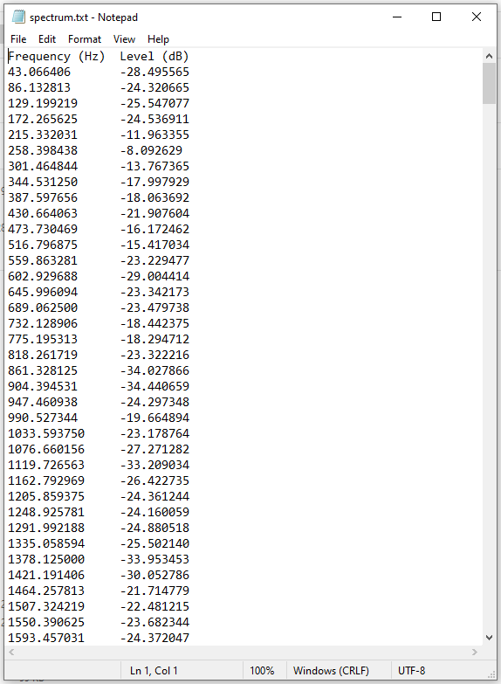

Figure 7. Exported output of Amplitude and Frequency Analysis

**6.2 COMPOSITION USING ANDROID**

SOFTWARE USED: ANDROID STUDIO(JAVA)

Steps to implement Vibration Patterns in Android:

1. Create an Empty Activity android studio project
2. Working with the activity_main.xml file

* Implement a single button in the layout which is used to create vibration waveforms, when pressed.
* Invoke the following code in the activity_main.xml file.

1. Seeking to vibrate permissions
   * Seeking to vibrate permission in AndroidManifest.xml file, because we are accessing the hardware part of the device.
   * Invoke the following code inside the AndroidManifest.xml file.
2. Working with the MainActivity.java file
   * + One of the important points to be noted here is, while creating the waveforms in a types array of long type, the first element needs to be zero(0). This is so because at the first instance the vibrator of the device needs to be turned on then made to vibrate for the further waveforms.
     + In this case the waveform is ***long[] vibrationWaveFormDurationPattern = {0, 10, 200, 500, 700, 1000, 300, 200, 50, 10};*** from the code below. And the first waveform is 0.
     + Invoke the following code in the MainActivity.java file. Comments are added inside the code to understand the code in more detail.

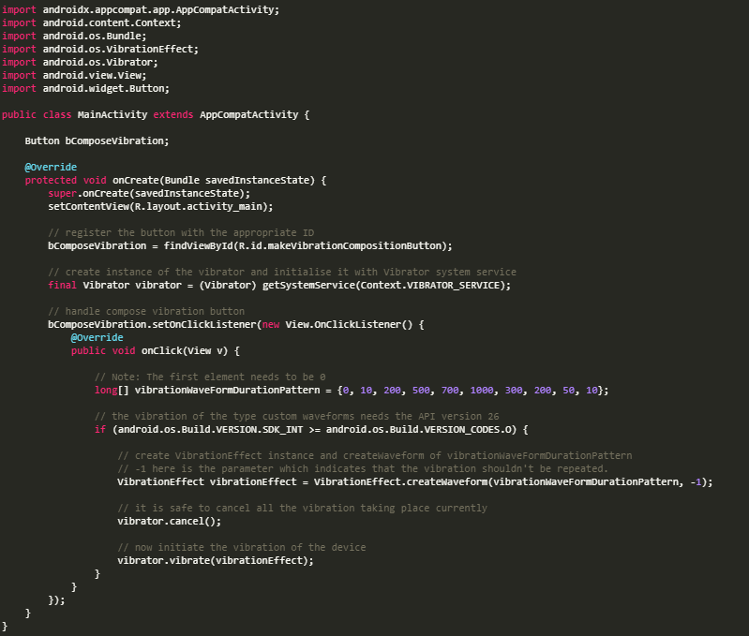

Figure 8 Vibration composition using manual customization

**\***Testing this application would be better in the physical Android devices with API version 26. *

* 1. **COMPOSITION USING HAPTIC COMPOSERS**

Software Used: Lofelt Studios (Haptic Composer)

Pre-rendering: Author small haptic files, known as haptic clips, derived from audio files. With the Studio frameworks, libraries, and game development plug-ins, you assign the clips to various events in the software for playback.

Real time: The Studio framework for iOS includes a special function which automatically converts audio from the application into haptics while the software is running.

The general workflow for authoring haptics is:

1. Load an audio file into the Studio desktop app.
2. Run the Audio Analyzer to generate the initial haptic effect.
3. Audition the haptic effect on the Studio mobile app on your phone. If necessary, edit the haptic effect in and validate the changes with the Studio mobile app.
4. Export the final haptic clip to disk.

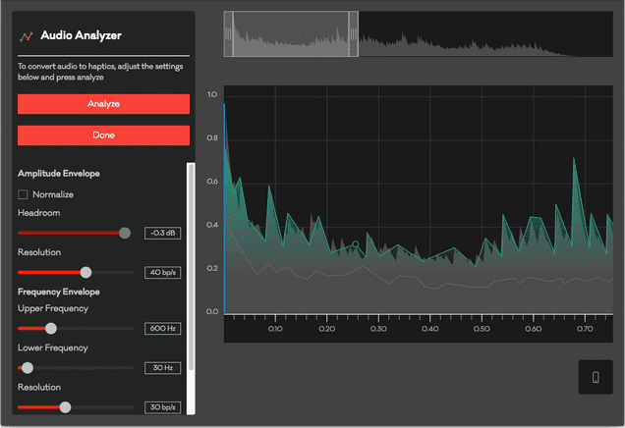

Figure 9. Audio Analysis using Lofelt Studio

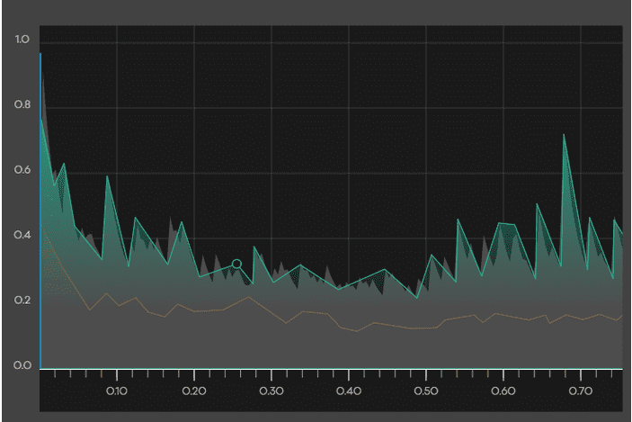

Figure 10. Manual editing using Lofelt

* With the Studio desktop app, it is possible to manually edit the haptics in case the Audio Analyzer didn't create the exact results you were looking for. The desktop app provides a graphical interface for editing the haptic curves, and you can immediately feel the results of any changes you make on your connected phone. Read the "Manually Editing Haptics" section for details.
* A window will appear in Studio desktop asking what type of haptic you'd like to export. The options are as follows:

Haptic: This is the device-agnostic format used by all the Lofelt Studio frameworks, libraries, and plug-ins. It will generate a file with a .haptic extension.

Ahap: This is the device-specific format used by Apple's Core Haptics API. It will generate a file with an. ahap extension.

**Important things to maintain while authoring haptic clips:**

1. Selection of vital Breakpoints
2. Selection and Adjustion of Empasis Amplitude.
3. Analysing Shapes generated for HD haptics. For Example,

First shape doesn’t give defined haptic feedback. Second one will create a slightly longer and slightly deeper Emphasis, somewhat like a "thud". Third shape creaptes the shortest and highest Emphasis possible, similar to the precise "tick" from a watch.

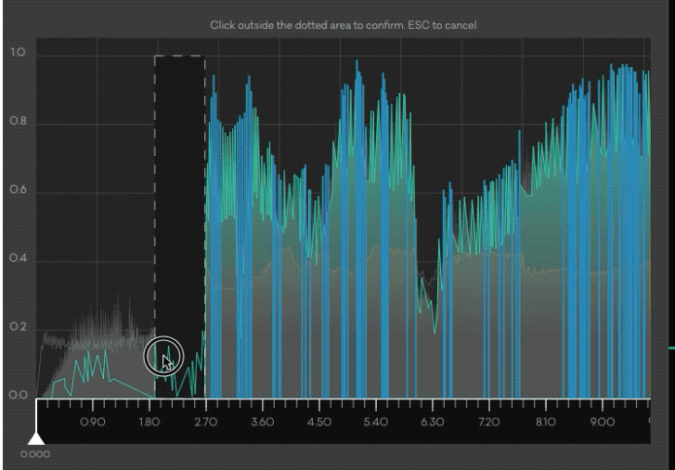

Figure 11. Audio analysis of music with longer time period

1. **APP DESIGN – USER INTERFACE**

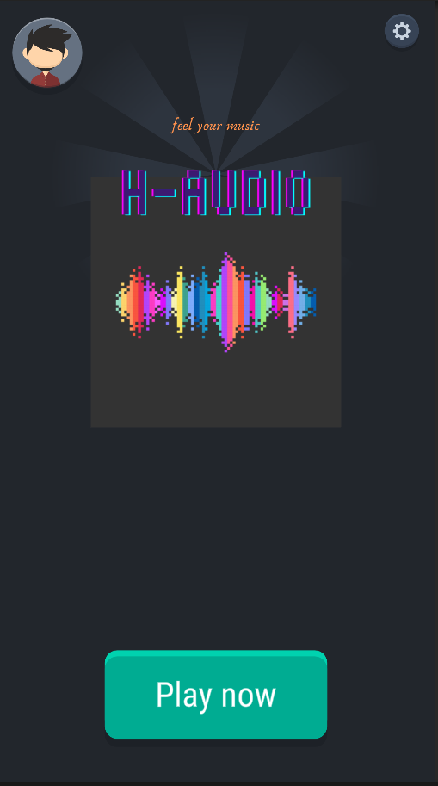 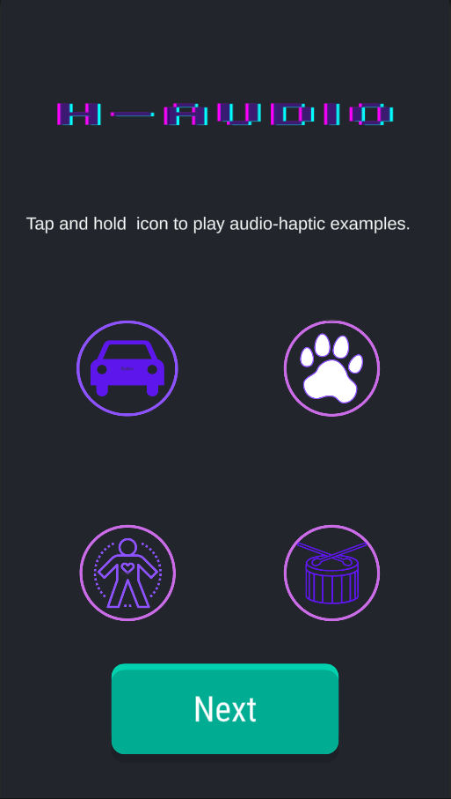

* 1. **BASIC SOUNDS**

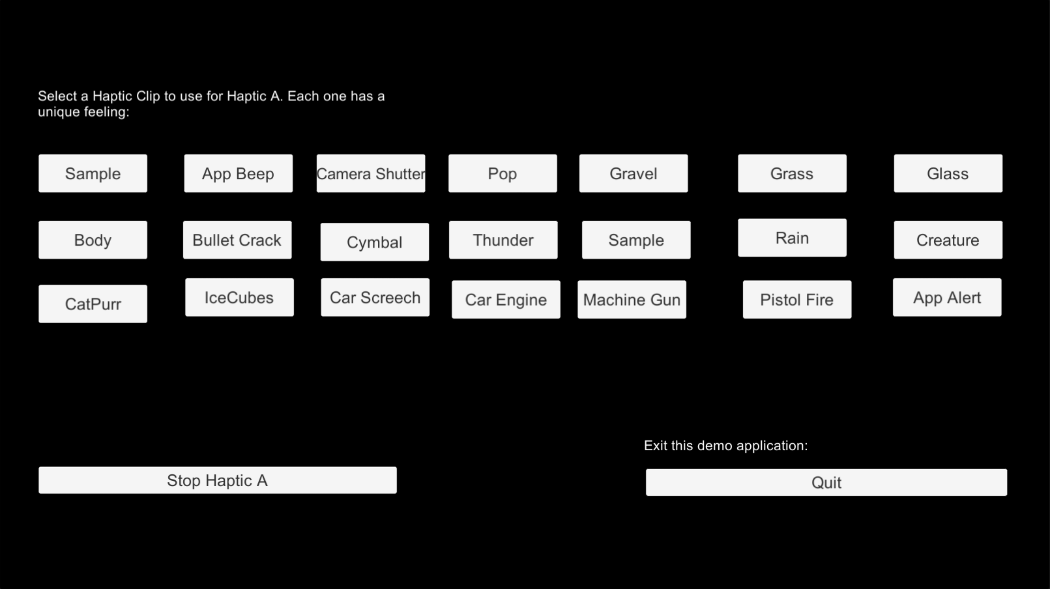

**7.2 EXPERIMENTAION**

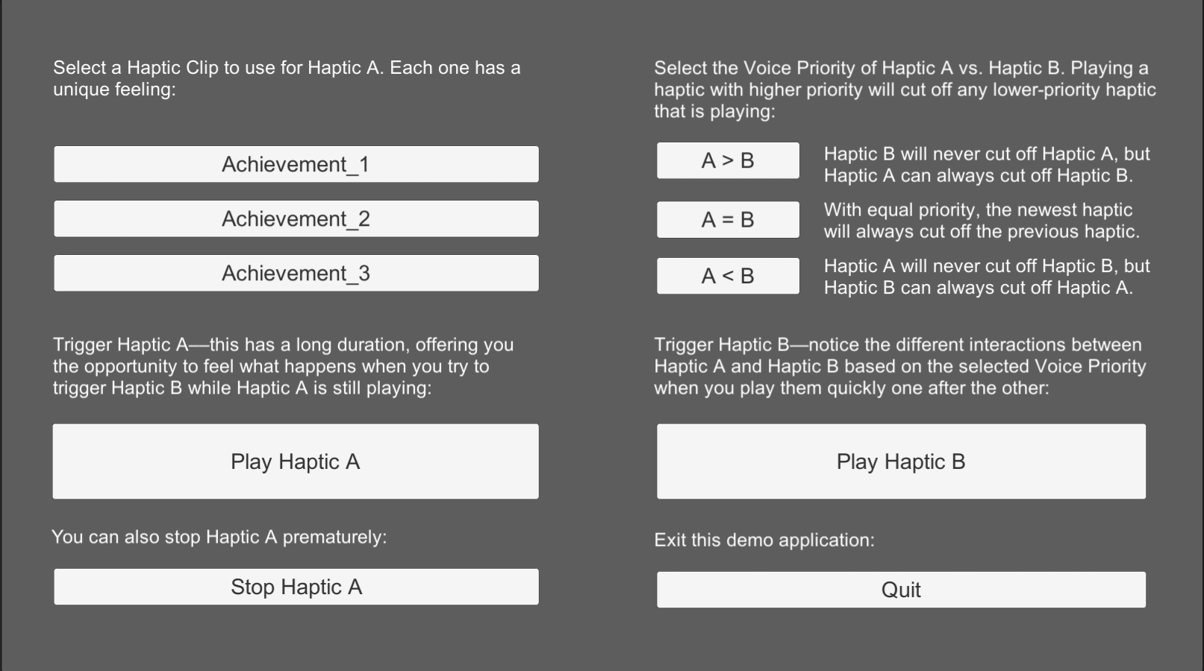

**7.3 DEVICE REQUIREMENTS**

For a user to experience the haptic affects, the user’s device (phone) must meet two criteria.

First, the device must have an adequate haptic actuator. In the case of Apple products, iPhones now include a Taptic Engine capable of reproducing haptics, but iPads do not. So, users will feel haptics when running your application on a compatible iPhone, but they will not when running the same application on an iPad.

Similarly, some Android phones and devices make use of ERM haptic actuators while some use LRA haptic actuators. ERM haptic actuators do not allow for intricate amplitude control while LRA actuators do. Lofelt Studio haptics will not work on Android phones or devices that use ERM haptic actuators.

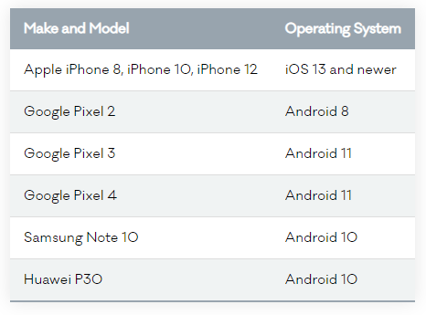

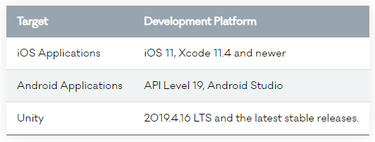

1. **RESULTS**

While experimenting with devices the following conclusions were derived.

1. **The intensity parameter is logarithmic, not linear. -** According to the Apple article on the AHAP file format, the HapticIntensity parameter is simply “The strength of the haptic event.” The parameter’s value is between 0.0 and 1.0.

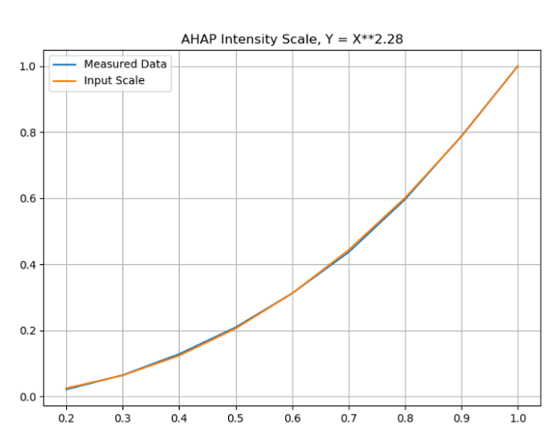

Figure 12The x axis here shows output acceleration; the y axis is the intensity parameter value. Note: These measurements relate only to iPhones.(python)

1. **Parameter curves are limited to 16 breakpoints. -** The AHAP data model might seem to support an unlimited amount of haptic data. But the breakpoints inside an AHAP file need to be written in blocks of 16 points. If a ParameterCurve has more than 16 points, the points beyond the 16th will be ignored
2. **Core Haptics doesn’t specify a hardware playback rate. -**In the audio world, there are clear standards and specifications for playing back high-quality sound. Consumer audio CDs, for example, use 16-bit audio sampled at 44.1 kHz, and the devices that play those CDs must play back 16-bit/44.1k audio. In the haptics domain, there are no equivalent standards or specifications. That’s a problem if you’re creating haptic experiences. You cannot consistently predict the experiences that will be delivered because the hardware used to produce each experience might downgrade the effects.
3. **The Core Haptics and Compose Vibration Audio Custom parameter has limitations.-** The AHAP file describes the haptic pattern that should be synchronized with the audio file. You can set the audio file’s location and playback start time with the AudioCustom event type. Unfortunately, there are a few limitations to that synchronized playback. First, it’s possible to invoke an error if you use an audio file that is too large.
4. **Parameter curves affect the entire AHAP pattern, not just single continuous events.-** it requires some effort and adds some complexity if you’re designing haptics manually. The only way for treating transients fully independently of continuous events is by playing them in separate AHAP files.
5. **The parameter curve for sharpness is additive modulation.**

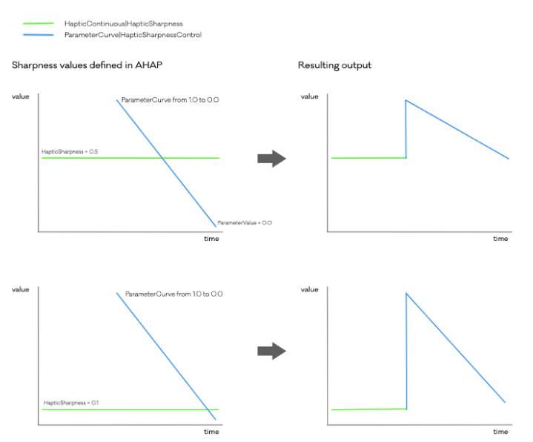

Figure 13.Haptic sharpness values defined in AHAP (left) versus actual output (right)

1. **Signal rendering for multiple haptic patterns can create phase cancellation.** - Haptic feedback uses a low frequency range. The Taptic Engine frequency range is 80 to 230 Hz, whereas the standard audio uses a range of 20 to 20,000 Hz. The low frequencies used for haptic feedback are prone to phase issues, which occur when two waves cancel each other out or create a beating effect**.**
2. **RESOURCES**

1. Agarwal, A.K., Namni, K., Kaczmarek, K.A., Tyler, M.E., Beebe, D.J.: A hybrid

natural/artificial electrostatic actuator for tactile stimulation. In: Proceedings

of the 2nd Annual Conference on Microtechnologies in Medicine and Biology,

Madison, Wisonsin, USA, pp. 341–345 (2002)

2. G¨u¸cl¨u, B., Oztek, C.: Tactile sensitivity of children: effects of frequency, masking, ¨

and the non-pacinian I psychophysical channel. J. Exp. Child Psychol. 98, 113–130

(2007)

3. G¨u¸cl¨u, B., Schepis, E.A., Yelke, S., Y¨ucesoy, C.A., Bolanowski, S.J.: Ovoid geometry of the pacinian corpuscle is not the determining factor for mechanical excitation.

Somatosens. Mot. Res. 23, 119–126 (2006)

4. G¨u¸cl¨u, B., Gescheider, G.A., Bolanowski, S.J., ˙

Istefanopulos, Y.: Population model

for vibrotactile spatial summation. Somatosens. Mot. Res. 22, 239–253 (2005)

5. G¨u¸cl¨u, B., Mahoney, G.K., Pawson, L.J., Smith, R.L., Bolanowski, S.J.: Localization of merkel cells in the skin: an anatomical model. Somatosens. Mot. Res. 25,

123–138 (2008)

6. G¨u¸cl¨u, B., Bolanovski, S.J.: Vibrotactile thresholds of the non-pacinian I channel:

I. Methodological issues. Somatosens. Mot. Res. 22, 49–56 (2005)

7. G¨u¸cl¨u, B., Bolanowski, S.J.: Frequency responses of cat rapidly adapting

mechanoreceptive fibers. Somatosens. Mot. Res. 20, 249–263 (2003)

8. G¨u¸cl¨u, B., Bolanowski, S.J., Pawson, L.: End-to-end linkage (EEL) clustering algorithm: a study on the distribution of meissner corpuscles in the skin. J. Comput.

Neurosci. 15, 19–28 (2003)

9. Shultz, C.D., Peshkin, M.A., Colgate, E.: Surface haptics via electroadhesion:

expanding electrovibration by Johnsen and Rahbek. In: Proceedings of the IEEE

World Haptics Conference (WHC 2015), Evanston, USA, pp. 57–62, June 2013

10. Meyer, D., Peshkin, M., Colgate, E.: Fingertip electrostatic modulation due to

electrostatic attraction. In: Proceedings of the IEEE World Haptics Conference

(WHC 2013), Daejeon, South Korea, pp. 43–48, April 2013

11. Wijekoon, D., Cecchinato, M.E., Hoggan, E., Linjama, J.: Electrostatic modulated

friction as tactile feedback: intensity perception. In: Isokoski, P., Springare, J. (eds.)

EuroHaptics 2012, Part I. LNCS, vol. 7282, pp. 613–624. Springer, Heidelberg(2012)

12. Cheng, D.K.: Fundamentals of Engineering Electromagnetics. Addison-Wesley,

Reading (1994)

13. Beebe, D.J., Heymel, C.M., Kaczmarek, K.A., Tyler, M.E.: A polyimide-on-silicon

electrostatic fingertip tactile display. In: Proceedings of the IEEE 17th Annual

Conference on Engineering in Medicine and Biology Society, Montreal, Que, pp.

1545–1546 (1995)

14. Vezzoli, E., Amberg, M., Giraud, F., Lemaire-Semail, B.: Electrovibration modeling

analysis. In: Auvray, M., Duriez, C. (eds.) EuroHaptics 2014, Part II. LNCS, vol.

8619, pp. 369–376. Springer, Heidelberg (2014)

15. Gescheider, G.A., Bolanovski, S.J., Pope, J.V., Verrillo, R.T.: A four-channel analysis of the tactile sensitivity of the fingertip: frequency selectivity, spatial summation, and temporal summation. Somatosens. Mot. Res. 19(2), 114–124 (2002)

16. Kim, H., Kang, J., Kim, K., Lim, K., Ryu, J.: Method for providing electrovibration

with uniformed density. IEEE Trans. Haptics 8(4), 492–496 (2015)

**THANK YOU**